DSA0502 – QUERY PROCESSING FOR DATA SCIENCE
LAB PROGRAMS
NAME: B KIRTHANAA REG. NO - 192324244
3.Write a Pandas program to display the details of jobs in descending sequence on Job Title.
Aim:
To create a jobs dataset using Pandas and display all job details sorted in descending order based on the Job Title.

CODE:
import pandas as pd
# Read dataset
jobs = pd.read_csv("Jobs.csv")
# Sort Job Title in descending order
result = jobs.sort_values(by="JobTitle", ascending=False)
print(result)

OUTPUT:
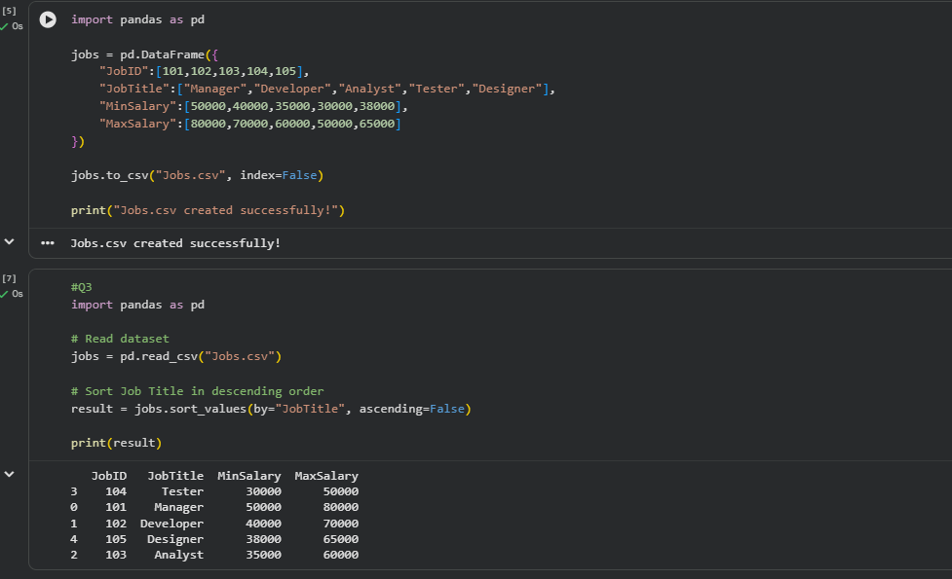
4.Write a Pandas program to create a line plot of the historical stock prices of Alphabet Inc. between two specific dates.

Aim:
To create a line graph showing Alphabet Inc. stock prices between two dates using Pandas and Matplotlib.

CODE:
import pandas as pd
import matplotlib.pyplot as plt

# Read dataset
stock = pd.read_csv("Alphabet.csv")

# Convert Date column
stock["Date"] = pd.to_datetime(stock["Date"])

# Select dates
data = stock[(stock["Date"] >= "2024-01-01") &
(stock["Date"] <= "2024-01-05")]

# Line plot
plt.plot(data["Date"], data["Close"], marker="o")
plt.title("Alphabet Inc. Stock Price")
plt.xlabel("Date")
plt.ylabel("Closing Price")
plt.grid(True)
plt.show()

OUTPUT:
